Smart water fountains

***DESIGN***

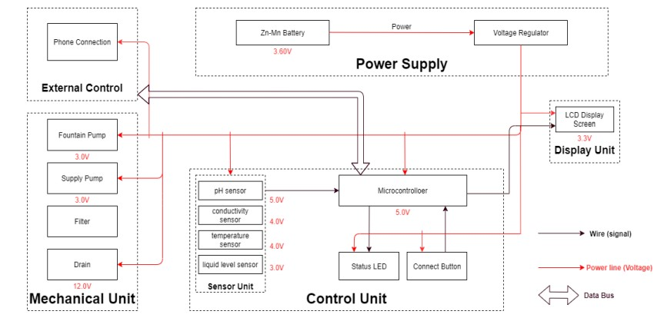

**1.Aesthetic Design:**

* + The overall style and theme of the fountain, which can range from traditional to modern, minimalist to ornate.
  + To view the materials that complement the surrounding environment, such as stone, glass, metal, or acrylic.
  + Incorporate decorative elements like sculptures, figurines, or unique basin designs to enhance the visual appeal.

l sensing

Power supply

Microcontroller setup

Water pump control

Water level sensing

Flow sensor

Water level sensing

Safety measure

Maintenance and monitoring

Safety measure

Wifi connectivity

Testing and calibration

Encloser and water proofing

LED lighting

Maintenance and monitoring

User interface

**2.Size and Location:**

* The size and scale of the fountain based on the available space and the desired visual impact.
* The location of the fountain, whether it's indoors or outdoors, and ensure that it fits seamlessly within the environment.

**3.Water Flow and Effects:**

* + the type of water flow and effects such as cascading waterfalls, laminar jets, or gentle bubbling.
  + Use multiple levels, tiers, or basins to create dynamic water patterns and maximize visual interest.

**4.Lighting Design:**

* + Integrate RGB LED lighting to illuminate the water and surrounding areas.
  + Plan the lighting effects, including color changes, intensity adjustments, and synchronized patterns to create a captivating visual display.

**5.Smart Technology Integration:**

* + - Microcontrollers or IoT devices to control the fountain's functions.
    - Smartphone app or touchscreen interface for user control.
    - Remote monitoring and control options for maintenance and adjustments.

**6.Interactive Features:**

* Interactive elements to engage users, such as touch-sensitive panels, proximity sensors, or responsive water jets that react to movement.

**7.Sound Design:**

* + The audio elements are soothing background music, nature sounds, or the calming sound of flowing water.

**9.Safety Measures:**

* + the safety of users by designing the fountain with protective barriers or covers for moving parts.
  + Incorporate features that prevent water splashing or overspray.

**10.Maintenance and Accessibility:**

* Design the fountain with easy access to components for maintenance and cleaning.
  + Include features like self-cleaning mechanisms or automated water treatment systems to reduce maintenance needs.

**11.Power and Water Supply:**

* + Determine the power source for the fountain's components, which may require electrical outlets or solar panels for sustainability.
  + Ensure a reliable water supply and a proper drainage system.

**12.Weather Resistance (for outdoor fountains):**

* If the fountain is outdoors, select materials that can withstand various weather conditions, including UV rays, rain, and freezing temperatures.

**Connectivity**

**Sensor Integration**

**Design and Prototyping**:

**Deployment and Scalability**

**User Interface and Interaction**

**Data Management**

IoT Sensor Design

TECHNOLOGICAL STACK